**Download and install the STS IDE (Spring Tool Suite)**

Spring Tool Suite is an IDE to develop spring applications.

1. Download Spring Tool Suite from <https://spring.io/tools3/sts/all>. Click on the platform which you are using

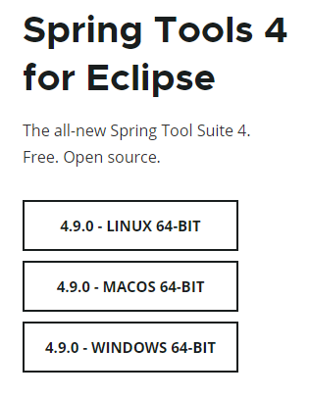

1. Select the windows 64 bit option
2. Go to download folder location, then double click on that file or Right click on file-> unzip it.
3. Go to sts-4.9.0.RELEASE folder.
4. Double click on SpringToolSuite4.exe file.
5. Spring too suite launcher box apprears on screen as

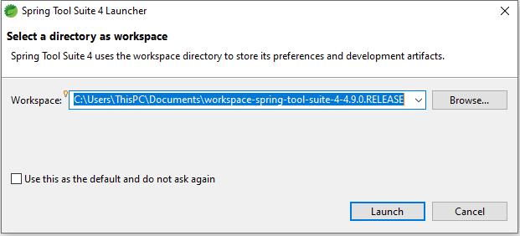

1. Set the workspace location as default or if you want you can change it.

Note- The best way is always create the workspace on any drive except c drive. Due to some system issue or virus you need to immediately format the c drive.

1. Click on launch button and it takes some time.
2. STS looks like

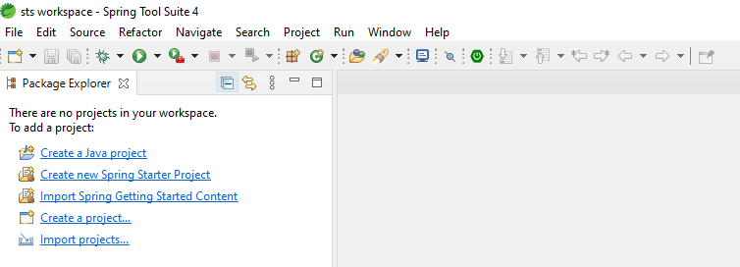

**Spring Boot-**

What is the Spring Boot?

Spring Boot is a spring framework module which provides RAD (Rapid ApplicationDevelopment) feature to the spring framework.

Features of spring boot

1. It allows avoiding heavy configuration of XML which is present in spring. in spring boot everything is auto-configured. We just need to use proper configuration for utilizing a particular functionality.
2. It includes embedded Tomcat-server, no need to add it manually.
3. Deployment is very easy, war and jar file can be easily deployed in the tomcat server.
4. Spring Application helps in the lazy initialization of the Spring applications. After enabling the lazy initialization, beans are created as per the requirement rather than during the application startup, which results in faster execution of the application. When enabling lazy initialization in a web application, some web-related beans are not initialized until an HTTP request is received.

**Pre-requisites**

* Java 1.8
* Maven 3.0+
* An IDE (Spring Tool Suite) is recommended.

**How to create the Spring Boot Maven Project-**

File->New-> Spring Starter Project-> dialog appears as

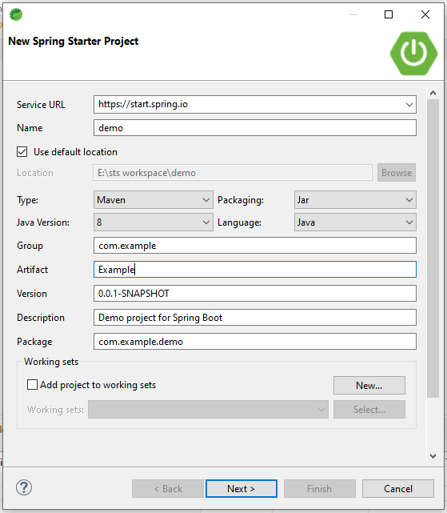

Enter the group id and artifact id and click on Next button.

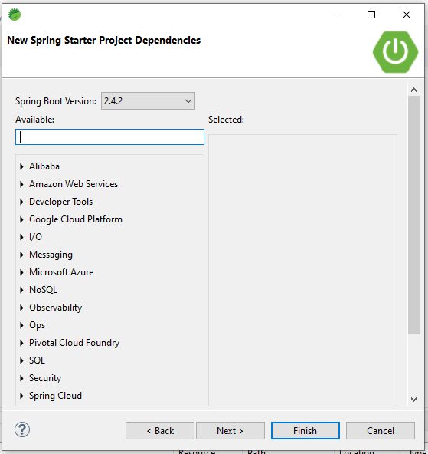

If you want, you can select the dependencies otherwise click on finish button.

Then

Project structure looks like as

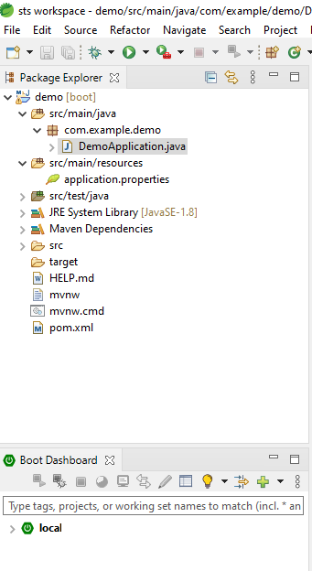

Note- @SpringBootApplication this annotation is equivalent to @Configuration, @ComponentScan, @EnableAutoConfiguration